CONTRACT PROBLEM:

PROBLEM DESCRIPTION:

Your job is to populate the expected receivables based on the contract payment terms.
Divide the amount based on the contract payment terms and insert those many records
in the expected record id.
This process helps the company/organization to know the amount they were expecting this month for planning.

Benefit: Planning and Budgeting users

CONTRACT_PAYMENT TERMS: It contains the following data

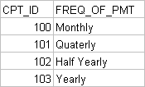

CONTRACT TABLE:

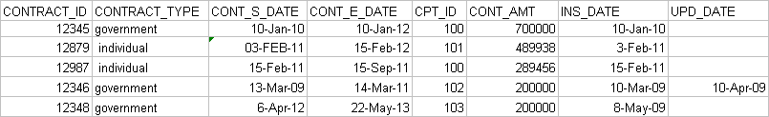

EXPECTED RECEIVABLE TABLE:

